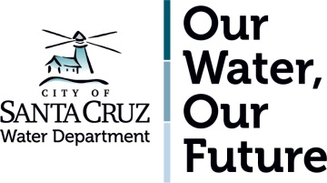

**CITY OF SANTA CRUZ WATER DEPARTMENT**

**GOOD NEIGHBOR COMMITMENT**

When the Santa Cruz Water Department undertakes construction projects in your neighborhood we are committed to being the best neighbor we can be. That means that neighbors can expect:

**Work to be conducted safely**

* Staff, consultants and contractors will properly use tools and equipment.
* Staff, consultants, and contractors will at all times comply with Cal OSHA requirements.
* Traffic control measures will be used when normal traffic flows are impacted.

**Construction to begin and end at scheduled times**

* For planned *non-emergency* work, construction hours will be adhered to.
* For *emergency* work, staff will adhere to the Good Neighbor Commitments to the extent practical and feasible, while addressing public health and safety issues related to the emergency.

**Staff and contractors working on projects to behave professionally**

* Appropriate language will be used.
* Non project-related noise will be kept to a minimum.
* Project debris will be removed.

**Project questions or concerns to be responded to**

* Project contact information will be available.
* Inquiries will be responded to within 2 business days.

**To receive regular project communication**

* Project descriptions, working hours and timelines will be provided in advance.
* Notification of regular (non-emergency) water service disruptions will be given 48 hours in advance.
* Unforeseen changes will be shared in as timely a manner as possible.

**Your neighborhood will be left in the same condition as it was when we arrived**

* Project sites will be maintained in a clean and orderly fashion.
* Excavations will be backfilled and patched when the project is complete.