Arana Gulch Coastal Prairie

Baseline Assessment Study: Summer 2013

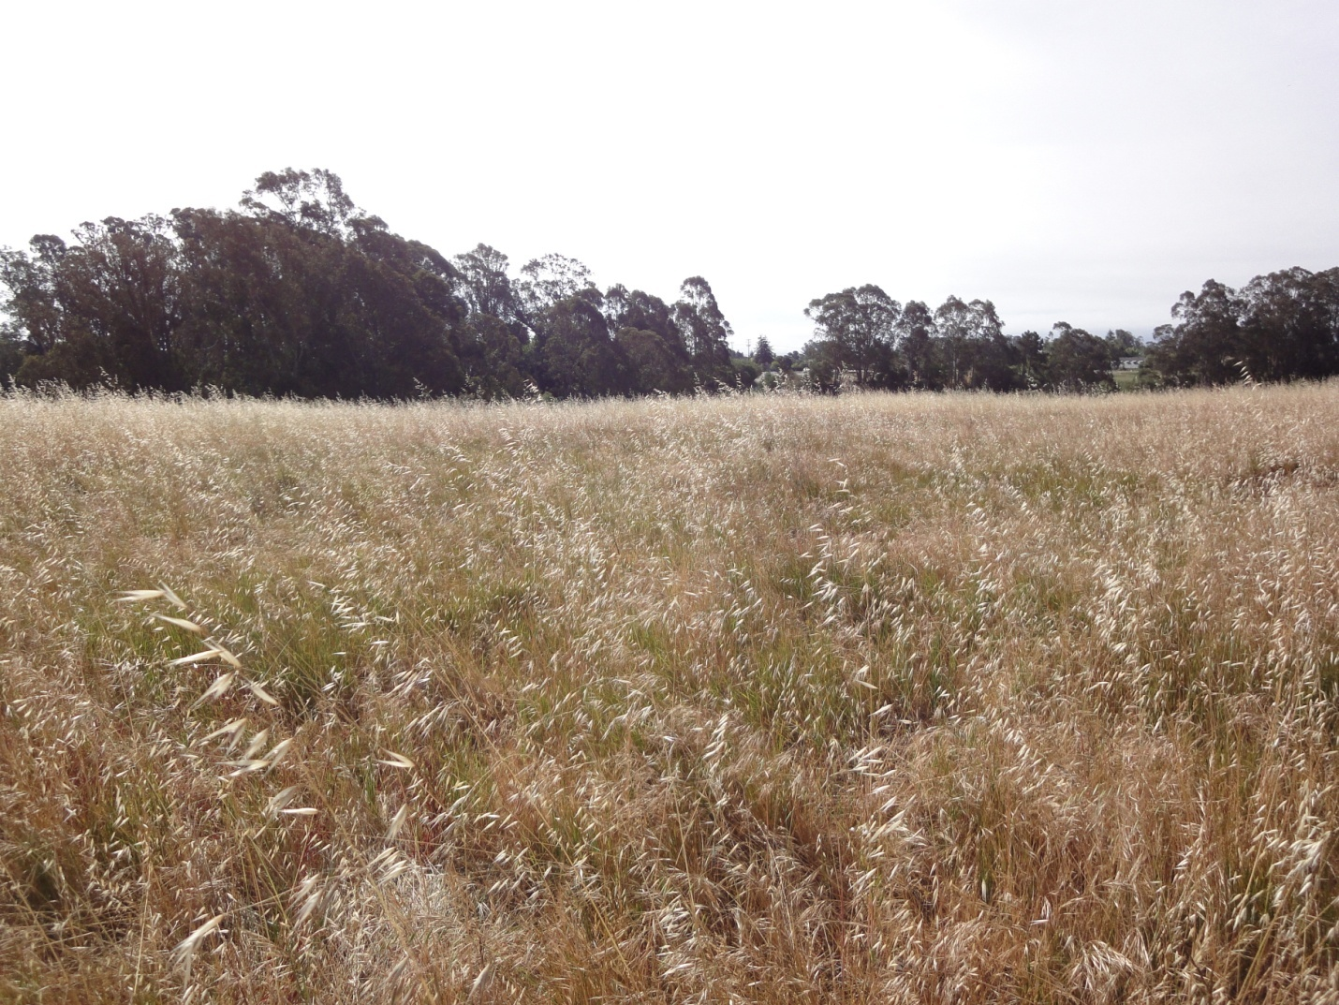

Prepared for the City of Santa Cruz Planning Department,

Department of Parks and Recreation,

and theArana Gulch Adaptive Management Working Group

Prepared by Alison E. Stanton, Research Botanist

3170 Highway 50 Suite # 7 South Lake Tahoe, CA 96150

January 2014

Table of Contents

Introduction 3

Methods 5

Results 9

Area A 11

Area C 14

Area D 16

Canopy height and summed cover 19

Discussion 20

Literature cited 22

# Introduction

A baseline assessment of vegetation conditions at Arana Gulch is one of the requirements of the Coastal Development Permit issued to the City of Santa Cruz by the California Coastal Commission. Section 3.7 of the Arana Gulch Habitat Management Plan (HMP) (Stanton 2013) describes the same purpose and justification of this summer baseline assessment of the Santa Cruz tarplant (SCT)/Coastal Prairie Management Area presented here including the details of field sample design and data analysis. The purpose of the baseline assessment is to characterize existing vegetation and ground cover conditions in areas that will be grazed under guidance of the Grazing Program specified in the HMP. Important monitoring variables include plant cover, canopy height, species richness, and ground cover. These data will enable a quantitative evaluation of changes in vegetation condition over time in response to grazing and will help the Arana Gulch Adaptive Management Working Group (AMWG) assess progress in meeting the specific goals and objectives of the HMP.

Arana Gulch has been subject to a long history of disturbance, including intensive agriculture and dairy farming. Cattle grazing stopped in 1988 and subsequent disturbance has taken the form of management actions performed by the City since 1994 including mowing, soil scraping, and two prescribed fires. During this time, the population of SCT experienced a steady decline after a brief population explosion in 1997-1998 following a 3 acre soil scraping and subsequent prescribed fire that coincided with the wettest winter on record. Reversing that decline in the SCT population is the first of four goals for the SCT and Coastal Prairie Management Area specified in the HMP:

Goal 1: Maintain a viable Santa Cruz tarplant (SCT) population at Arana Gulch.

Goal 2: Reintroduce grazing to restore a disturbance regime that maintains functioning coastal prairie.

Goal 3: Minimize the detrimental effects of high non-native plant cover and restore coastal prairie species diversity and habitat function.

Goal 4: Maintain a genetically and demographically viable soil seed bank in perpetuity.

The yearly census of SCT that occurs in late summer in July or August will be used to assess progress toward meeting specific objectives of Goal 1. Likewise, an initial soil seed assessment conducted in December 2013 will set a baseline for measuring progress toward Goal 4. This baseline assessment study addresses coastal prairie habitat conditions and was specifically designed to evaluate whether grazing can meet the following objectives under Goal 3 to restore coastal prairie species diversity and habitat function:

Objective 3A: Reduce canopy height during the basal rosette stage for SCT (November-April) from the baseline level to a level that enables SCT plants to complete their lifecycle (0.5m or less) by 2015.

Objective 3B: Reduce the cover of non-native species in the coastal prairie from the baseline level to one more representative of a reference functioning coastal prairie system by 2020.

Objective 3C: Increase cover of native species from baseline levels to one more representative of a reference functioning coastal prairie system by 2020.

Objective 3D: Increase native species richness from baseline levels to one more representative of a reference functioning coastal prairie system by 2020.

Objective 3E: Increase the cover of bare ground in the coastal prairie from the baseline level to a level that enables SCT plants to complete their lifecycle by 2015.

The objectives do not specify acceptable numeric levels for vegetation cover, species richness, or amount of bare ground and instead refer to reference functioning coastal prairie as the desired standard. What it means to be a functioning coastal prairie has been characterized in different ways and depends on many factors including the position of the coastal terrace, soil type, hydrology, dominant species, and past land-use history (Stromberg et al 2001). A past study of California coastal grasslands concluded that past cultivation was the one factor that most strongly negatively affects native cover and species richness (Stromberg and Griffin 1996). Intensive tilling alters soil stratigraphy, topography, drainage, and the soil microbial communities, resulting in conditions conducive to exotic species invasion and a depleted native seed bank. Establishing realistic numeric vegetation objectives for the vegetation in Arana Gulch will require consideration of the intensive past land-use history at the site along with this baseline assessment, future monitoring data, and data from the literature.

We recognize that 2013 was not the best year to conduct a vegetation baseline. Data was collected in the first week of June, which was weeks past peak reproduction. Ideally, the assessment would have occurred in April or early May. However, the first AMWG meeting was not convened until late April and then review of the draft sample design and contracting issues caused a delay in implementation. In addition, although precipitation was higher than normal in November and December, 2012 it was much lower than normal the rest of the spring in 2013 (Table 1). Precipitation during the water year from July 1, 2012 to June 30, 2013 totaled only 20.7 inches. This is about 2/3 of the long term average of 30 inches. However, it was necessary to get data from at least one baseline year before construction began.

Table 1. Monthly rainfall (inches) over the last two years at the Santa Cruz NOAA weather station, including the 111 year average.

|  |  |  |  |  |  |  |  |  |  |  |  |  |  |
| --- | --- | --- | --- | --- | --- | --- | --- | --- | --- | --- | --- | --- | --- |
|  | **JAN** | **FEB** | **MAR** | **APR** | **MAY** | **JUN** | **JUL** | **AUG** | **SEP** | **OCT** | **NOV** | **DEC** | **ANN** |
| **111 yr MEAN** | 6.14 | 5.42 | 4.33 | 1.92 | 0.8 | 0.22 | 0.06 | 0.07 | 0.42 | 1.39 | 3.31 | 5.24 | 30.04 |
| S.D. | 4.13 | 3.94 | 3.05 | 1.86 | 1.05 | 0.36 | 0.3 | 0.19 | 0.96 | 1.42 | 2.78 | 3.97 | 9.55 |
|  |  |  |  |  |  |  |  |  |  |  |  |  |  |
| **2012** | 3.68 | 0.94 | 7.38 | 3.1 | 0.06 | 0.19 | 0 | 0 | 0 | 0.53 | 5.56 | 7.95 | 29.39 |
| **2013** | 0.92 | 0.32 | 1.7 | 0.88 | 0.02 | 0.03 | 0.01 | 0.02 | 0.11 | 0.06 | 0.31 | 0.11 | 4.49 |

Initiating the Grazing Program at Arana Gulch is contingent on the completion of the fences and other necessary infrastructure. Construction began in early November 2013 and it is expected that grazing may begin by the end of 2014 or early 2015. Therefore, a second year of baseline data can be obtained more quickly and at a lower cost in 2014. However, with only 0.62 inches of rain in the first 6 months of the 2013/2014 water year, it has been the driest period since record keeping began in 1893. Previously, the last six months of 1958 was the driest period, with only 1.5 inches. The low precipitation may make collection of a second year of baseline assessment data in 2014 a less than optimal scenario, but it can at least be timed to occur during peak reproduction.

# Methods

The coastal prairie occupies about 30 acres at Arana Gulch. Fences will be constructed on the interior of the new trails to form three grazing enclosures that correspond to historic and current SCT population locations (Figure 1). The total area within the grazing enclosures is about 18.75 acres (8.4 hectares) divided as follows:

Area A = 651,763 sq ft or 15 acres (6 ha)

Area C = 177,340 sq ft or 4.1 acres (1.6 ha)

Area D Area D=92,269 sq ft or 2.1 acres (0.9 ha)

We used satellite imagery on Google Earth to select starting points for 25m point intercept vegetation transects in each of the grazing enclosures. We selected a total of 8 points in A, 6 in C, and 4 in D using a stratified approach to get good coverage within each unit. Figure 2 shows transect placement across the prairie

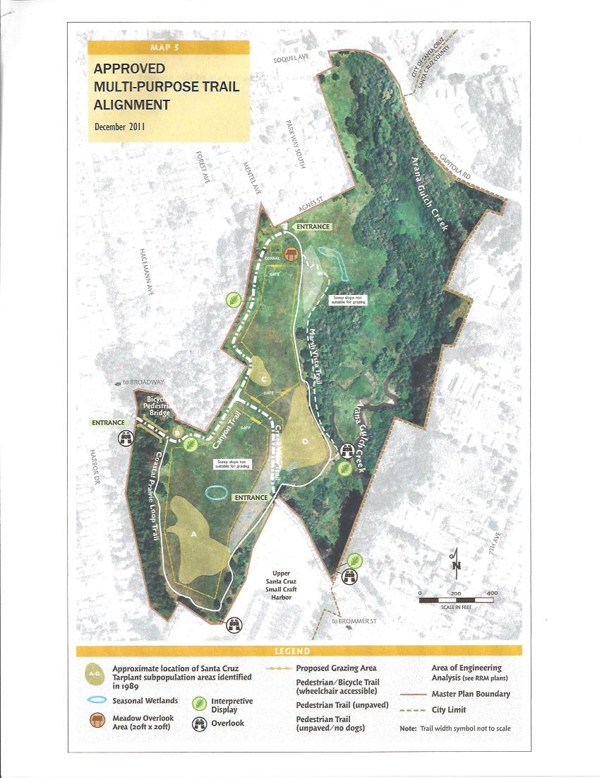

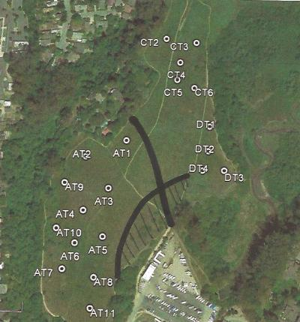

Figure 2. Permanent transect placement on the coastal prairie at Arana Gulch. (The dark center line represents approximate location of central trail and the area with has lines is a steep slope outside the grazing area.)

Field work was conducted from June 10-12, 2013. In the field, we used GPS to locate the pre-selected starting point for each 25m transect and then used a random compass bearing to establish the line. The range of available compass bearings was limited as necessary to insure that there was at least a 5m buffer with future fences, existing dirt trails, or other features that needed to be avoided. Transects were oriented in a southern direction in Areas A and C but it was not possible to do that in the small confines of Area D. We pounded one half inch rebar posts into the ground at both ends of the transect and installed plastic rebar caps for safety. We then took a photo from 0m looking along the length of transect with a whiteboard held up at the 5m point labeled with the transect number and date. On the data sheet we recorded the GPS coordinates, compass bearing, elevation, slope, and aspect of the transect.

The point intercept method was used to assess changes in plant species cover and ground cover for each enclosure. This method uses a narrow diameter sampling pole that is slowly lowered to the ground. Plant species or ground cover classes that touch the pin are recorded as “hits” along a transect. Percent cover is calculated by dividing the number of hits for each plant species or ground cover class by the total number of points along a transect.

We recorded “hits” of each species encountered by the pole at every 0.5m along the 25m line for a total of 50 points per transect. We identified all species at each point and recorded the ground cover code (litter, bare, gopher disturbance, basal vegetation, rock). We also measured the average height of the low canopy layer and the high canopy layer at the 6, 12, 18, and 24 m points. It was not possible to measure thatch depth since we could not distinguish residue from the previous year’s growth (thatch) from senescent material from earlier in the growing season (litter). Thatch and litter were both included in the ground cover code of litter. In addition, we conducted a search within a 5m belt transect, using the transect as the centerline, and recorded the presence of any plant species that was not encountered on the transects. This additional method is often used to capture uncommon or rare species and more fully characterize species richness.

**Data analysis**

The percent cover for each species on a transect is equal to the number of hits multiplied by 2. The transect is the sample unit and for each we calculated the percent cover by species, the total number of species encountered, and the % ground cover of litter, bare, gopher, basal vegetation, and rock. We also calculated average vegetation height (cm) of the low and high canopy layers for each transect. Cover values were grouped by guilds: exotic annual forb (EAF), exotic annual grass (EAG), exotic perennial forb(EPF), exotic perennial grass (EPG), native annual forb(NAF), native annual grass (NAG), native perennial forb (NPF), and native perennial grass (NPG).

We used field sampling and power analysis to determine sample size for each enclosure. We first sampled 5 of the 6 pre-selected transects in Area C. One of the points was in an area completely infested with a dense and large stand of Italian thistle (*Carduus pycnocephalus*) that we had to avoid. On that first set of data we conducted a power analysis using a statistical power calculator provided by DSS Research (http://www.dssresearch.com/toolkit/sscalc/size_a1.asp). This enabled us to test how much change we can detect by comparing the average cover and standard deviation values recorded for the 5 transects to a fixed value that is 2.5 or 5% greater than that value. We accepted an 80% power level (β = 0.2) and α = 0.1 based on standard practice. For Area C, a sample size of 5 transects provided sufficient power, so we did not install the additional transect. In Area A, after sampling all 8 transects we determined that we needed an additional 3 transects for a sample size of 11. In Area D, the 4 transects were sufficient.

# Results

Among the 20 transects sampled, a total of 26 species were recorded as hits or within the 5m belt transects (125m2) that were searched along each transect (Table 1). An additional 9 species (including 2 unknown species) were observed only within the belt transects. Of these 35 species, only 6 species were native. We presume the 2 unknowns were also native. In addition to the sampling, we observed very small patches or individuals of three native perennial grasses (*Nassella pulchra*, *Bromus carinatus,Hordeum brachyanthera)* in Area A. Other observed natives included a few blue-eyed grass (*Sysyrinchium bellum*), several soap plants (*Chlorogalum pomeridianium*), foothill sedge (*Carex tumilicola*), and a *Camissonia sp.* All of these native species were so sparsely distributed that they were not captured by our sampling.

Several areas were excluded from sampling, including the recently mowed areas for the perimeter fuel break, and the mapped seasonal wetlands that are identified on the approved trail map. Although the wetland in Area A will be inside the fencing, it supported only a small (<20m radius) cluster of wild rye (*Elymus triticoides*), and including that area in the sampling would have just increased the variation for the unit. A better approach for monitoring would be to outline the patch with GPS and do a targeted sampling. The seasonal wetland near Area D falls outside of the grazing enclosures but could be monitored with a similar method. Historic SCT Area B will also be outside of the grazing enclosure. While the HMP does not specify any monitoring strategy for the area, the AMWG has expressed interest in discussing management options for Area B and in monitoring other areas outside of the fences in order to track potential recruitment of desirable species or invasive weed movement.

Table 1. Species recorded during the 2013 summer baseline assessment at Arana Gulch. Life forms utilize the following codes: exotic annual forb(EAF), exotic annual grass (EAG), exotic perennial forb(EPF), exotic perennial grass (EPG), native annual forb(NAF), native annual grass (NAG), native perennial forb (NPF), and native perennial grass (NPG).

|  |  |  |  |  |
| --- | --- | --- | --- | --- |
| **Scientific name, TJM 2** | **Area(s) found** | **Common name** | **Life form** | **Family** |
| Avena fatua | A,C,D | Wild oat | EAG | POACEAE |
| Briza maxima | A,D | Rattlesnake grass | EAG | POACEAE |
| Briza minor | A,D | Quaking grass | EAG | POACEAE |
| Bromus diandrus | A,C | Ripgut brome | EAG | POACEAE |
| Bromus hordeaceus | A,D | Soft chess | EAG | POACEAE |
| Carduus pycnocephalus | C | Italian thistle | EPF | ASTERACEAE |
| Cerastium glomeratum | C | Mouse-ear chickweed | EAF | CARYOPHYLLACEAE |
| Convolvulus arvensis | A,C,D | Bindweed | EPF | CONVOLVULACEAE |
| Danthonia californica | A | California oatgrass | NPG | POACEAE |
| Elymus triticoides | D | wild rye | NPG | POACEAE |
| Erodium botyrs | A,C | long bill stork's beak | EAF | GERANIACEAE |
| Erodium cicutarium | A,D | red stem filaree | EAF | GERANIACEAE |
| Eschscholzia californica | A | California poppy | NPF | PAPAVERACEAE |
| Holcus lanatus | A,CD | velvet grass | EPG | POACEAE |
| Hypochaeris glabra | A,C,D | Smooth cat's-ear | EAF | ASTERACEAE |
| Juncus patens | A,C,D | Spreading rush | NPG | JUNCACEAE |
| Festuca perennis (Lolium multiflorum) | A,C,D | Italian ryegrass | EAG | POACEAE |
| Plantago lanceolata | A,C,D | English plantain | EPF | PLANTAGINACEAE |
| Raphanus sativus | A,C,D | wild radish | EAF | BRASSICACEAE |
| Rosa californica | A | California rose | Shrub | ROSACEAE |
| Rumex acetosella | A,D | Sheep sorrel | EPF | POLYGONACEAE |
| Rumex crispus | A,C | Curly dock | EPF | POLYGONACEAE |
| Trifolium subterraneum | A | Subterranean clover | EAF | FABACEAE |
| Veronica americana | A | American brooklime | EAF | PLANTAGINACEAE |
| Vicia sativa subsp. sativa | A,C,D | common vetch | EPF | FABACEAE |
| Festuca myuros (Vulpia myuros var. myuros) | A,C,D | Rattail six weeks grass | EAG | POACEAE |
| **OTHER SP. DETECTED IN 5M BELTS** |  |  |  |  |
| Baccharis pilularis | A | Coyote brush | Shrub | ASTERACEAE |
| Cirsium vulgare | D | Bull thistle | EPF | ASTERACEAE |
| Lactuca serriola | D | Prickly lettuce | EPF | ASTERACEAE |
| Lotus cornicultatus | A | bird's foot trefoil | EPF | FABACEAE |
| Mentha pulegium | A,C | Mentha pulegium | EPF | LAMIACEAE |
| Onorpordum acanthium | A,C | Scotch Thistle | EPF | ASTERACEAE |
| Tragopogon pratensis | A,C,D | Salsify | EPF | ASTERACEAE |

## Area A

The 11 transects installed in Area A occurred within an elevation range of 10-24m. In all cases the slope was relatively flat with no particular aspect. The transects were oriented within a compass bearing range spanning 154° to 273°.

Plant cover data was calculated for 22 species (Figure 3). Cover values for several species were as low as 0.18%. *Festuca myurous* was the most dominate species with 77.6% cover, followed by *Avena fatua* with 48.5% cover. The third highest cover values were shared among *Bromus diandrus*, *Erodium cicutarium*, and *Raphanus sativa*.



Figure 3. Mean percent cover of 22 species sampled in Area A at Arana Gulch. Each error bar is constructed using 1 standard error from the mean.

Exotic annual grasses (EAG) were most dominant with a mean cover of 22.4% followed by exotic annual forbs (EAF) with 7.2% (Figure 4). Native perennial grass (NPG) had slightly greater cover (3.4%) than exotic perennial forbs (EPF) (2.4%). *Danthonia californica* comprised the majority of the NPG cover, while *Juncus patens* was encountered only 4 times. The very patchy distribution of *Danthonia californica* is illustrated by significant cover values (24 and 44%) recorded on 2 transects, while the other 9 had none. Cover of native perennial forbs (NPF) was represented solely by scattered individuals of *Eschscholozia californica*, while the shrub cover was present as a single clump of *Rosa californica*.



Figure 4. Mean percent cover of 6 plant guilds sampled across Area A at Arana Gulch. Each error bar is constructed using 1 standard error from the mean.

Ground cover hits were only recorded once per transect, so percent cover sums to 100%. Litter and basal vegetation accounted for 70% of the ground cover with equal distribution, while bare ground and disturbance mounds from gophers accounted for the remaining 30% (Figure 5).



Figure 5. Mean ground cover recorded on 11 transects in Area A at Arana Gulch. BAVEG = basal vegetation. Each error bar is constructed using 1 standard error from the mean.

A total of 23 species were recorded as hits along the transects in Area A and the 5m belt transect added an additional 5 species for a total of 28 species (see Table 1). On average, only 9 species were recorded on each transect and just under 4 species within each belt transect, for a total of 13.4 species in each 125 m2 plot (Table 2). Native species richness was <1.

Table 2. Mean number of species recorded along 25 m transects and detected within a 5m belt in Area A (with one standard deviation in parentheses).

|  |  |
| --- | --- |
| Species Richness | Area A |
| # Species per transect | 9.45 (2.73) |
| # Additional species in plot | 3.91 |
| Total # species/125 m2 | 13.36 (3.85) |
|  |  |
| # Native species per transect | 0.36 (0.50) |
| # Additional native sp. in plot | 0.27 (2.47) |
| Total # native species/125 m2 | 0.63 (0.50) |

## Area C

The 5 transects installed in Area C occurred within an elevation range of 14-35m. Transect CT3 was slightly sloped (6 °) with an eastern aspect (70°) but the slopes of the other 4 were flat with no particular aspect. The transects were oriented within a compass bearing range spanning 157° to 212°.

Plant cover data was calculated for 12 species (Figure 6). Cover of *Lactuca seriola* was only 0.40%, while *Festuca myurous* was the most dominate species with 68% cover, followed by *Avena fatua* with 48.4% cover. The third highest cover values were shared among *Raphanus sativa*(31.4%),  *Bromus diandrus* (24%), *Lolium multiflorum* (19%)*,* and *Erodium cicutarium* (17.2%)



Figure 6. Mean percent cover of 12 species sampled in Area C at Arana Gulch. Each error bar is constructed using 1 standard error from the mean.

Exotic annual grasses (EAG) were most dominant with a mean cover of 33% followed by exotic annual forbs (EAF) with 16.9% (Figure 7). Cover of exotic perennial forbs (EPF) (2.4%) was represented by *Convovulus arvensis* and *Vicia sativa*. No native species were captured by the transect sampling.



Figure 7. Mean percent cover of 3 plant guilds sampled across Area C at Arana Gulch. Each error bar is constructed using 1 standard error from the mean.

Litter accounted for 44% of the ground cover, while bare ground and basal vegetation together accounted for 48% of cover. Disturbance mounds from gophers accounted for the remaining 4% (Figure 8).



Figure 8. Mean ground cover recorded in Area C at Arana Gulch. BAVEG = basal vegetation. Each error bar is constructed using 1 standard error from the mean.

A total of 15 species were recorded as hits along the transects in Area C and the 5m belt transect added an additional 3 species for a total of 18 species (see Table 1). On average, only 8 species were recorded on each transect and just over 4 species within each belt transect, for a total of 12.6 species in each 125 m2 plot (Table 2). Two native species, *Juncus patens* and an unknown monocot, were detected in the belt transect.

Table 3. Mean number of species recorded along 25 m transects and detected within a 5m belt in Area C (with one standard deviation in parentheses).

|  |  |
| --- | --- |
|  | Area B |
| # Species per transect | 8 (1.0) |
| # Additional species in plot | 4.60 |
| Total # species per 125 m2 | 12.6 (2.7) |
|  |  |
| # Native sp. per transect | 0.00 |
| # additional native sp. in plot | 1 (2.07) |
| Total # native sp. per 125m2 | 1 (1.0) |

## Area D

The 4 transects installed in Area D occurred within an elevation range of 10-19m. Slopes were about 2 to 3° with SE aspects. Because of the small space available, transects were not oriented in a southern direction and instead ranged across a compass bearing range spanning 21° to 343°.

Plant cover data was calculated for 16 species (Figure 9). Cover values for *Plantago lanatus* was lowest at 0.50% while *Festuca myurous* was the most dominate species with 70% cover, followed by *Erodium cicutarium* with 52.5% cover. The third highest cover values were shared among *Avena fatua*(23%), *Bromus diandrus* (14%), *B. hordeaceous* (15%), and the invasive perennial *Holcus lanatus* (17.5%).

Area D exhibited a more mixed community where exotic annual grasses (EAG), exotic annual forbs (EAF), and exotic perennial grasses (EPG) had similar cover values (Figure 10). *Holcus lanatus* comprised the entire EPG guild. Likewise, *Leymus triticoides* was the only native perennial grass (NPG), although *Juncus patens* was detected once. *Rumex acetosella* was the only exotic perennial forb (EPF).



Figure 9. Mean percent cover of 16 species sampled in Area D at Arana Gulch. Each error bar is constructed using 1 standard error from the mean.



Figure 10. Mean percent cover of 5 plant guilds sampled across Area D at Arana Gulch. Each error bar is constructed using 1 standard error from the mean.

Litter and basal vegetation accounted for over 80% of the ground cover, while bare ground and disturbance mounds from gophers accounted for the remaining (Figure 11).



Figure 11. Mean ground cover recorded on 4 transects in Area D at Arana Gulch. BAVEG = basal vegetation. Each error bar is constructed using 1 standard error from the mean.

A total of 16 species were recorded as hits along the transects in Area D and the 5m belt transect added an additional 3 species for a total of 19 species detected (see Table 1). On average, 10.25 species were recorded on each transect and 4.5 additional species within each belt transect, for a total of 14.75 species in each 125 m2 plot (Table 4). Native species richness was <1.

Table 4. Mean number of species recorded along 25 m transects and detected within a 5m belt in Area A (with one standard deviation in parentheses).

|  |  |
| --- | --- |
| Species Richness | Area D |
| # Species per transect | 10.25 (1.5) |
| # Additional species in plot | 4.5 (2.6) |
| Total # species/125 m2 | 14.75 (1.25) |
|  |  |
| # Native species per transect | 0.50 (1.0) |
| # Additional native sp. in plot | 0.25 (0.5) |
| Total # native species/125 m2 | 0.75 (0.95) |

## Canopy height and summed cover

The average height of the low canopy was nearly identical in units A and D (39.5 and 38.1 cm, respectively) while it was higher in Unit D (59 cm) (Figure 12). In contrast, the average height of the maximum canopy was nearly identical in units A and C (122.4 and 125.7 cm, respectively) and much lower in unit D (86.3 cm). The minimum canopy was comprised mainly of *Festuca myuros* in all units and the high canopy was *Avena fatua* often mixed with *Raphanus sativa*.

Plant cover was summed for each guild by transect and then the mean was calculated to illustrate the dense multi-layered canopy present throughout the coastal grassland for all three units (Figure 13). Absolute plant cover in all units was over 200%. The composition of the units was fairly similar with most differences explained by differences in cover of just one or two species. For instance, unit D had high cover of *Erodium cicutarium* (EAF) and the greatest cover of *Holcus lanata* (EPG) and consequently there was slightly less cover of EAGs than in the other units. All plant guilds were present in Unit A expect for EPG, but *Holcus lanta* was detected in the belt transects. Unit C was comprised almost exclusively of EAF and EAG.





Figure 12. Mean canopy height in Units A, C, and D at Arana Gulch. Each error bar is constructed using 1 standard error from the mean.





Figure 13. Mean summed cover of all plant guilds in Units A, C, and D at Arana Gulch. Each error bar is constructed using 1 standard error from the mean.

# Discussion

The purpose of this baseline assessment is to provide initial data on the vegetation conditions at Arana Gulch that will help determine whether the Grazing Program is successful in meeting the goals and objectives of the HMP. The HMP objectives under Goal 3 call for a decline in the cover of non-native species and an increase in the cover of native species to a level that is more representative of a “reference” coastal prairie. In addition, the objectives call for a concomitant increase in native species richness and a decrease in the canopy height and an increase in the amount of bare ground to levels that will allow SCT to germinate and establish more successfully.

In June 2013, the sampled coastal prairie vegetation at Arana Gulch was comprised almost exclusively of non-native species with very high cover and a tall canopy height. The prairie could be characterized as a fairly uniform non-native annual grassland comprised of a tall layer (>1 m) of *Avena fatua* and/or *Raphanus sativa*  along with a mix of several species of annual grasses and then a shorter ubiquitous layer of *Festuca myuros.* Native species richness was very low, with only 6 native species recorded across all transects. Native cover averaged <5% in Areas A and D, represented only by small and localized patches of *Danthonia californica* and *Elymus triticoides*, scattered individuals of *Eschscholozia californica* and *Juncus patens*, and single clumps of *Rosa californica* and *Baccharis pilularis.* No native species were recorded in Area C. A total of 7 other native species were observed on the coastal prairie along with two unknowns that we presumed were natives.

Differences among the three samples areas were apparent, and are possibly related to past management actions and topography. The area north of the main E-W trail, including Area C, has not been mowed annually except around the perimeter for a fire break. In contrast, the area south of the main E-W trail, including Area A, has been mowed annually (often twice per year), but not since 2011. Greater exotic forb and exotic grass diversity was recorded in Area A compared to the Areas C or D, but that variation was most apparent in localized areas that were scraped recently (2010 or 2011) and even in the one location that was scraped around 1997. The vegetation in Area D has also been mowed regularly, but it was mainly differentiated by a fairly large infestation of *Holcus lanata* and the prevalence of *Rumex acetosella* and *Erodium cicutarium* in the grass matrix. Canopy height was also shorter in Area D which has a steeper slope and a south eastern aspect in contrast to the undulating, but relatively flat main terrace.

Limited data on vegetation conditions at reference coastal prairies is available. One of the most recent unpublished studies collected data on vegetation conditions at 6 reference coastal prairie sites situated between Point Lobos and Davenport, but not surprisingly Arana Gulch was excluded from the study because of low native cover compared to the rest of the sites (Holl and Reed, 2010).The reference sites sampled in that study exhibited a wide range of variation in native species cover (20-40%) and the number of native species recorded per transect varied from a low of 4 to a high of 21. In Hayes and Holl (2003), native grass cover was 30-35%, while native perennial forb cover was 10 -15%.

Given the degraded conditions at Arana and the past intensive agricultural usage, the goal of restoring the system to the level of functioning reference coastal prairie may be very difficult to achieve. Coastal California grasslands that have been tilled have less native plant diversity and richness (Stromberg and Griffin 1996) and are resistant to change and difficult to restore (Corbin et al 2004). However, during the development of the HMP there was not yet any baseline data to characterize existing conditions and so the acceptable restoration criterion became a return to an ideal of a functional reference coastal prairie. Establishing more specific achievable objectives for the vegetation at Arana Gulch will be a necessary next step in the monitoring program.

The 2013 dataset has its limitations from the late timing of the data collection. The annual forbs were all dry by June and it is very likely that annual diversity and some earlier season perennial diversity was under-detected in the sample. A survey earlier in 2014 will hopefully fill in some of the gaps. But, as already mentioned, the incredibly dry conditions at Arana Gulch at the start of 2014 may further confound a second year of baseline data collection. Even if the final baseline dataset remains less than optimal and represents drier than normal conditions, these data can help the AMWG begin refining the objectives under Goal 3.

Even if the first year of grazing coincides with a much wetter winter that makes it difficult to know whether observed changes in canopy height, baregound, or non-native cover were from the grazing or the precipitation, it is really the direction of change that matters the most. An observed decrease in canopy height and non-native cover at Arana Gulch could be declared an interim success. The highest priority goal is improved recruitment of SCT, so an increase in the number of plants at the site would also be an interim success. The opposite scenario could not be declared a failure, however. It could take longer than one year for SCT to respond to grazing and changes in vegetation, especially if conditions remain dry.

# Literature cited

Corbin, J.D., D'Antonio, C.M., and Bainbridge, S.J., 2004. Tipping the balance in the restoration of native plants. In: Gordon, M.S., Bartol, S.M. (Eds.), Experimental approaches to conservation biology. University of California Press, Berkeley, CA, pp. 154-179.

Hayes, G.F., and Holl, K.D. 2003b. Site-specific responses of native and exotic species to

disturbances in a mesic grassland community. *Applied Vegetation Science* **6**, 235-244.

Holl, K.D., and Reed, L.K., 2010. Reference and baseline samplings of Younger Lagoon Natural Reserve -2010. Unpublished report prepared for the California Coastal Commission.

Stanton, A.E. 2013. Habitat Management Plan for Arana Gulch. Unpublished report prepared for the City of Santa Cruz and the California Coastal Commission.

Stromberg, M.R., and Griffin, J.R. 1996. Long-term patterns in coastal California grasslands in relation to cultivation, gophers, and grazing. *Ecological Applications* **6**, 1189-1211.

Stromberg, M. R., Kephart, P., and Yadon, V. 2001. Composition, invasibility, and diversity in

coastal California grasslands. Madroño **48**, 236-52.