Arana Gulch Coastal Prairie

Baseline Assessment Study: Spring 2014

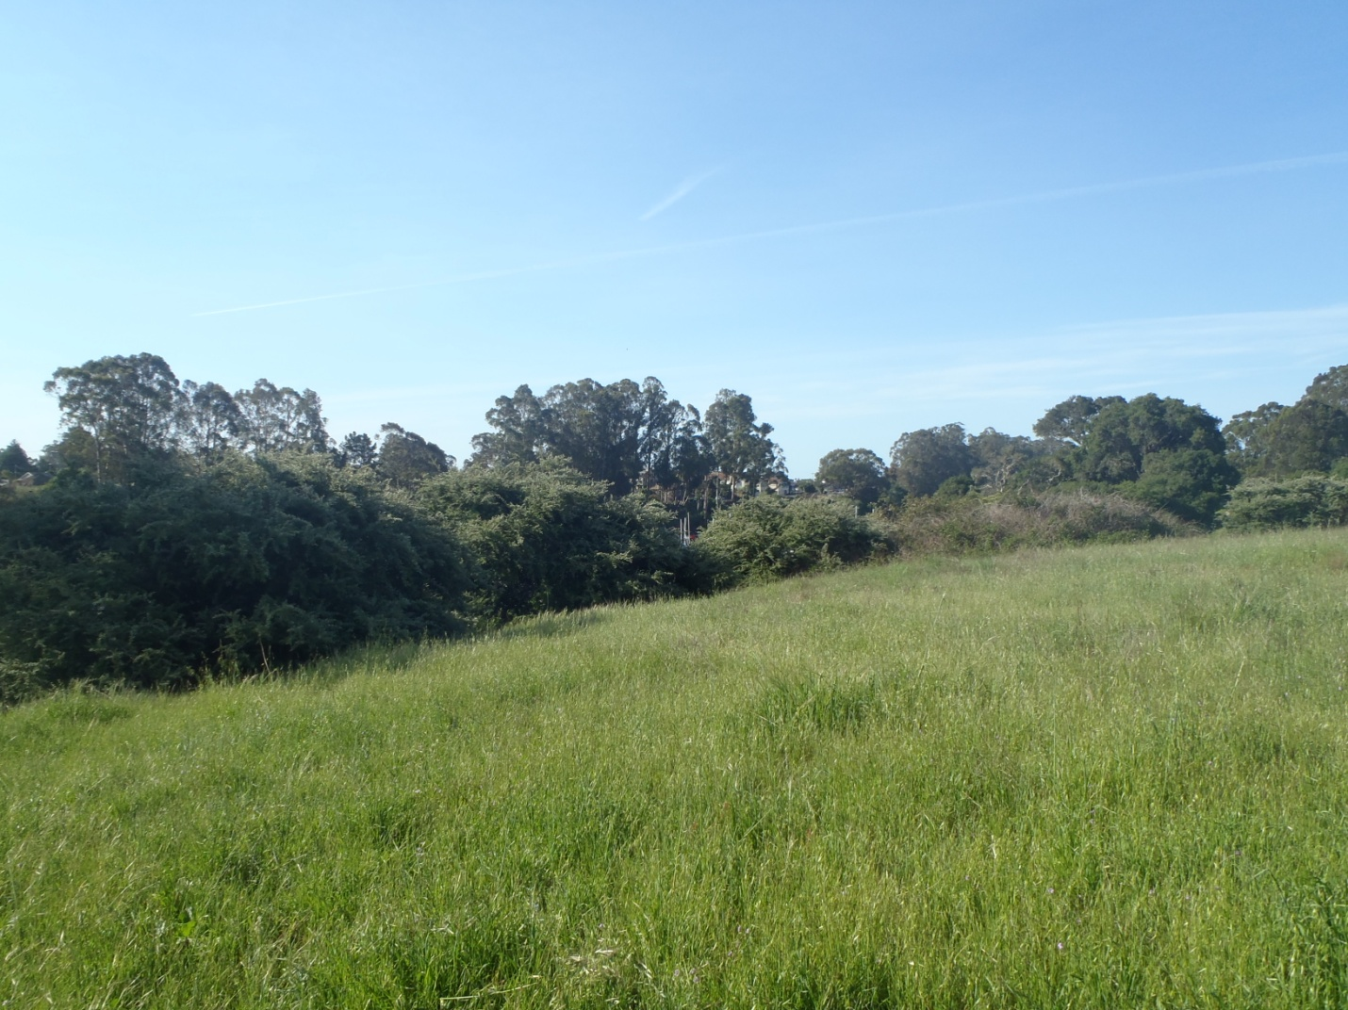

Prepared for the City of Santa Cruz Planning Department,

Department of Parks and Recreation,

and theArana Gulch Adaptive Management Working Group

Prepared by Alison E. Stanton, Research Botanist

3170 Highway 50 Suite # 7 South Lake Tahoe, CA 96150

June 2014

Table of Contents

Introduction 3

Methods 5

Results 7

Area A 9

Area C 11

Area D 12

Canopy height and summed cover 14

Discussion 16

Literature cited 17

Appendix A 2013 and 2014 baseline monitoring photos 17

# Introduction

A baseline assessment of vegetation conditions at Arana Gulch is one of the requirements of the Coastal Development Permit issued to the City of Santa Cruz by the California Coastal Commission. Section 3.7 of the Arana Gulch Habitat Management Plan (HMP) (Stanton 2013) describes the purpose and justification of this baseline assessment of the Santa Cruz tarplant (SCT)/Coastal Prairie Management Area presented here including the details of field sample design and data analysis. The purpose of the baseline assessment is to characterize existing vegetation and ground cover conditions in areas that will be grazed under guidance of the Grazing Program specified in the HMP. Important monitoring variables include plant cover, canopy height, species richness, and ground cover. These data will enable a quantitative evaluation of changes in vegetation condition over time in response to grazing and will help the Arana Gulch Adaptive Management Working Group (AMWG) assess progress in meeting the specific goals and objectives of the HMP.

Arana Gulch has been subject to a long history of disturbance, including intensive agriculture and dairy farming. Cattle grazing stopped in 1988 and subsequent disturbance has taken the form of management actions performed by the City since 1994 including mowing, soil scraping, and two prescribed fires. During this time, the population of SCT experienced a steady decline after a brief population explosion in 1997-1998 following a 3 acre soil scraping and subsequent prescribed fire that coincided with the wettest winter on record. Reversing that decline in the SCT population is the first of four goals for the SCT and Coastal Prairie Management Area specified in the HMP:

Goal 1: Maintain a viable Santa Cruz tarplant (SCT) population at Arana Gulch.

Goal 2: Reintroduce grazing to restore a disturbance regime that maintains functioning coastal prairie.

Goal 3: Minimize the detrimental effects of high non-native plant cover and restore coastal prairie species diversity and habitat function.

Goal 4: Maintain a genetically and demographically viable soil seed bank in perpetuity.

An initial soil seed assessment conducted in December 2013 will set a baseline for measuring progress toward Goal 4. This baseline assessment study addresses coastal prairie habitat conditions and was specifically designed to evaluate whether grazing can meet the following objectives under Goal 3 to restore coastal prairie species diversity and habitat function:

Objective 3A: Reduce canopy height during the basal rosette stage for SCT (November-April) from the baseline level to a level that enables SCT plants to complete their lifecycle (0.5m or less) by 2015.

Objective 3B: Reduce the cover of non-native species in the coastal prairie from the baseline level to one more representative of a reference functioning coastal prairie system by 2020.

Objective 3C: Increase cover of native species from baseline levels to one more representative of a reference functioning coastal prairie system by 2020.

Objective 3D: Increase native species richness from baseline levels to one more representative of a reference functioning coastal prairie system by 2020.

Objective 3E: Increase the cover of bare ground in the coastal prairie from the baseline level to a level that enables SCT plants to complete their lifecycle by 2015.

The objectives do not specify acceptable numeric levels for vegetation cover, species richness, or amount of bare ground and instead refer to reference functioning coastal prairie as the desired standard. What it means to be a functioning coastal prairie has been characterized in different ways and depends on many factors including the position of the coastal terrace, soil type, hydrology, dominant species, and past land-use history (Stromberg et al 2001). A past study of California coastal grasslands concluded that past cultivation was the one factor that most strongly negatively affects native cover and species richness (Stromberg and Griffin 1996). Intensive tilling alters soil stratigraphy, topography, drainage, and the soil microbial communities, resulting in conditions conducive to exotic species invasion and a depleted native seed bank. Establishing realistic numeric vegetation objectives for the vegetation in Arana Gulch will require consideration of the intensive past land-use history at the site along with this baseline assessment, future monitoring data, and data from the literature.

The purpose of the 2014 spring baseline assessment in the coastal prairie at Arana Gulch was to re-sample the permanent point intercept vegetation transects installed in June, 2013. Trail construction at the site began in early November 2013 and grazing will not begin until all construction and the fences are completed later in 2014. This timing made it possible to obtain a second year of baseline data.

Unfortunately, the 2013/2014 water year has been one of the driest periods since record keeping began in 1893. Precipitation during the water year from July 1, 2013 to June 30, 2014 totaled only 5.34 inches (Table 1). In contrast, precipitation in the 2012-2013 year was 18.91 inches. The long term average for the Santa Cruz NOAA weather station is 30 inches.

Table 1. Monthly rainfall (inches) over the last two years at the University of California Cooperative Education (UCCE) station at DeLaveaga.

|  |  |  |  |  |  |  |  |  |  |  |  |  |  |
| --- | --- | --- | --- | --- | --- | --- | --- | --- | --- | --- | --- | --- | --- |
| Water year | [Jul](http://celake.ucanr.edu/about/weather_202/?weather=monthlyinfo&station=104&month=7) | [Aug](http://celake.ucanr.edu/about/weather_202/?weather=monthlyinfo&station=104&month=8) | [Sep](http://celake.ucanr.edu/about/weather_202/?weather=monthlyinfo&station=104&month=9) | [Oct](http://celake.ucanr.edu/about/weather_202/?weather=monthlyinfo&station=104&month=10) | [Nov](http://celake.ucanr.edu/about/weather_202/?weather=monthlyinfo&station=104&month=11) | [Dec](http://celake.ucanr.edu/about/weather_202/?weather=monthlyinfo&station=104&month=12) | [Jan](http://celake.ucanr.edu/about/weather_202/?weather=monthlyinfo&station=104&month=1) | [Feb](http://celake.ucanr.edu/about/weather_202/?weather=monthlyinfo&station=104&month=2) | [Mar](http://celake.ucanr.edu/about/weather_202/?weather=monthlyinfo&station=104&month=3) | [Apr](http://celake.ucanr.edu/about/weather_202/?weather=monthlyinfo&station=104&month=4) | [May](http://celake.ucanr.edu/about/weather_202/?weather=monthlyinfo&station=104&month=5) | [Jun](http://celake.ucanr.edu/about/weather_202/?weather=monthlyinfo&station=104&month=6) | Total |
| 2013-2014 | 0.01 | 0.02 | 0.11 | 0.06 | 0.31 | 0.11 | 0.01 | 2.85 | 1.36 | 0.42 | 0.03 | 0.05 | 5.34 |
| 2012-2013 | 0 | 0 | 0 | 0.11 | 5.97 | 8.96 | 0.92 | 0.32 | 1.7 | 0.88 | 0.02 | 0.03 | 18.91 |

The very dry conditions represents a less than optimal scenario for a baseline assessment. However, two years of vegetation and ground cover data is preferable to one year when it comes to evaluating the changes expected from grazing and the Objectives addressed under goal 3 of the HMP. Together these data can help the AMWG begin refining the objectives under Goal 3 to create better conditions for SCT germination and establishment

# Methods

The same point intercept method was used in 2014. We recorded “hits” of each species encountered by a pole at every 0.5m along a 25m line for a total of 50 points per transect. We identified all species at each point and recorded the ground cover code (litter, bare, gopher disturbance, basal vegetation, rock). We also measured the average height of the low canopy layer and the high canopy layer at the 6, 12, 18, and 24 m points. It was not possible to measure thatch depth since we could not distinguish residue from the previous year’s growth (thatch) from senescent material from earlier in the growing season (litter). Thatch and litter were both included in the ground cover code of litter. In addition, we conducted a search within a 5m belt transect, using the transect as the centerline, and recorded the presence of any plant species that was not encountered on the transects. This additional method is often used to capture uncommon or rare species and more fully characterize species richness. Photos were taken from the 0m with the camera at eye level and a white board with the name of the transect and compass bearing.

The survey was conducted on April 21-22, in advance of a scheduled AMWG recommended mowing of the coastal prairie on April 24. In Unit C, CT1 was never installed in 2013 because it was in thick patch of Italian thistle and several transects were destroyed by the construction access road. Transect CT4 was eliminated and only the 0 meter mark of CT5 was present so we re-installed the 25m end using a new compass bearing. In addition, CT3 and CT6 were not re-located, but it is possible that the re-bar is intact and will become apparent once the grazing starts. To have a sufficient sample size two new transects were installed at CT 7 and CT8 (Figure 1).

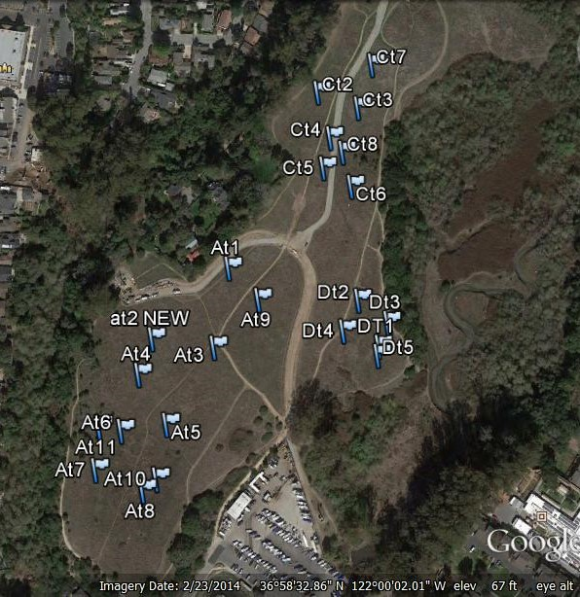

Figure 1. Permanent transect placement on the coastal prairie at Arana Gulch in 2014. (The dark center line represents approximate location of central trail and the area with hash lines is a steep slope outside the grazing area.)

To establish new transects, we used the same method as in 2013 using GPS to locate a pre-selected starting point and then using a random compass bearing to establish the line. The range of available compass bearings was limited as necessary to insure that there was at least a 5m buffer with future fences, existing dirt trails, or other features that needed to be avoided.

In Unit A, AT2 was destroyed by the construction road and staging for the Hagemann Gulch bridge. A new AT2 was installed south of the staging area. A new 25m mark was installed for AT4 because it had been destroyed by a new user trail. All other transects in Unit A were intact. In Unit D, a new 25m mark was installed at DT3. DT1 and DT2 were not located, so DT 2 was re-installed and a new DT5 was installed. DT4 was intact.

**Data analysis**

In 2013 we conducted a power analysis using a statistical power calculator provided by DSS Research (http://www.dssresearch.com/toolkit/sscalc/size_a1.asp ) to determine sample size for each enclosure. For Area C, a sample size of 5 transects provided sufficient power. In Area A, after sampling all 8 transects we determined that we needed an additional 3 transects for a sample size of 11. In Area D, 4 transects were sufficient.

To calculate percent cover for each species on a transect the number of hits was multiplied by 2 because there were 50 points. The transect is the sample unit and for each we calculated the percent cover by species, the total number of species encountered, and the % ground cover of litter, bare, gopher, basal vegetation, and rock. We also calculated average vegetation height (cm) of the low and high canopy layers for each transect. Cover values were grouped by guilds: exotic annual forb (EAF), exotic annual grass (EAG), exotic perennial forb (EPF), exotic perennial grass (EPG), native annual forb(NAF), native annual grass (NAG), native perennial forb (NPF), and native perennial grass (NPG).

We present a comparison between the 2013 and 2014 cover data by guild with error bars constructed using one standard deviation from the mean. However, no statistical tests were performed because no management was applied in either year and differences are due to the sample timing (June in 2013 and April in 2014) and a large difference in precipitation as described in Table 1.

# Results

Among the transects sampled, a total of 33 species were recorded as hits or within the 5m belt transects (125m2) that were searched along each transect (Table 2). In 2013, a total of 32 species were recorded. Purple needle grass (*Nassella pulchra*) was not recorded on the transects in 2013, but otherwise the species were the same. The only native species detected were California oatgrass (*Danthonia californica*), California poppy (*Eschscholozia californica*), California rose (*Rosa californica),* Great Basinwildrye *(Elymus triticoides),* and spreading rush *(Juncus patens).* Coyote bush (*Baccharis pilularis*) and coast live oak (*Quercus agrifolia*) were also present within the 5m belts in Area A. All other species were non-native.

Table 2. Species recorded during the 2014 summer baseline assessment at Arana Gulch. Life forms utilize the following codes: exotic annual forb(EAF), exotic annual grass (EAG), exotic perennial forb(EPF), exotic perennial grass (EPG), native annual forb(NAF), native annual grass (NAG), native perennial forb (NPF), and native perennial grass (NPG).

|  |  |  |  |  |
| --- | --- | --- | --- | --- |
| **Scientific name, TJM 2** | **Area(s) found** | **Common name** | **Life form** | **Family** |
| Anagallis arvensis | A,C,D | Scarlet pimpernel | EAF | PRIMULACEAE |
| Avena fatua | A,C,D | Wild oat | EAG | POACEAE |
| Briza maxima | A,D | Rattlesnake grass | EAG | POACEAE |
| Briza minor | A,D | Quaking grass | EAG | POACEAE |
| Bromus diandrus | A,C | Ripgut brome | EAG | POACEAE |
| Bromus hordeaceus | A,D | Soft chess | EAG | POACEAE |
| Carduus pycnocephalus | C | Italian thistle | EPF | ASTERACEAE |
| Cerastium glomeratum | C | Mouse-ear chickweed | EAF | CARYOPHYLLACEAE |
| Convolvulus arvensis | A,C,D | Bindweed | EPF | CONVOLVULACEAE |
| Danthonia californica | A | California oatgrass | NPG | POACEAE |
| Elymus triticoides | D | wild rye | NPG | POACEAE |
| Erodium botyrs | A,C | long bill stork's beak | EAF | GERANIACEAE |
| Erodium cicutarium | A,D | red stem filaree | EAF | GERANIACEAE |
| Eschscholzia californica | A | California poppy | NPF | PAPAVERACEAE |
| Festuca perennis (Lolium multiflorum) | A,C,D | Italian ryegrass | EAG | POACEAE |
| Geranium dissectum | D | Cutleaf geranium | EAF | GERANIACEAE |
| Holcus lanatus | A,CD | velvet grass | EPG | POACEAE |
| Hypochaeris glabra | A,C,D | Smooth cat's-ear | EAF | ASTERACEAE |
| Juncus patens | A,C,D | Spreading rush | NPG | JUNCACEAE |
| Nassella pulchra | A | Purple needle grass | NPG | POACEAE |
| Plantago lanceolata | A,C,D | English plantain | EPF | PLANTAGINACEAE |
| Raphanus sativus | A,C,D | wild radish | EAF | BRASSICACEAE |
| Rosa californica | A | California rose | Shrub | ROSACEAE |
| Rumex acetosella | A,D | Sheep sorrel | EPF | POLYGONACEAE |
| Rumex crispus | A,C | Curly dock | EPF | POLYGONACEAE |
| Trifolium subterraneum | A | Subterranean clover | EAF | FABACEAE |
| Vicia sativa subsp. sativa | A,C,D | common vetch | EPF | FABACEAE |
| Festuca (Vulpia )myuros | A,C,D | Rattail six weeks grass | EAG | POACEAE |
| **OTHER SP. DETECTED IN 5M BELTS** |  |  |  |  |
| Baccharis pilularis | A | Coyote brush | Shrub | ASTERACEAE |
| Genista monspessulana | D | French Broom | Shrub | FABACEAE |
| Lactuca serriola | C,D | Prickly lettuce | EPF | ASTERACEAE |
| Quercus agrifolia | A | Coast live oak | Tree | FAGACEAE |
| Tragopogon pratensis | A,C,D | Salsify | EPF | ASTERACEAE |

French broom was the only invasive species with a High Cal-IPC (Invasive Plant Council) rank that was recorded. It is in Area D and was captured by the sampling in one 5m belt transect. Scotch thistle (*Onorpordum acanthium*) is also a High species that was recorded in sampling in 2013 in Areas A and C, but it was not captured in 2014. A total of three forb species are ranked Moderate including Italian thistle (Carduus pycnocephalus), bull thistle (*Cirsium vulgare*), and sheep sorrel (*Rumex acetosella*). The perennial velvet grass (*Holcus lanatus*) and three annuals grasses, wild oat (Avena fatua), ripgut brome (*Bromus diandrus*) and rattail six weeks grass (Fetuca myuros), are considered Moderate because of the intense effect these grasses can have on fire regime and their ability to exclude natives.

The photos from each transect line are included separately as Appendix A.

## Area A

Area A is the only unit where SCT have been observed in recent years. Plant cover data was calculated for 19 species (Figure 2). *Avena fatua* was the most dominate species with 45% cover, followed by *Festuca myurous* with 35% cover. The third highest cover values were shared among *Bromus diandrus*, *Erodium cicutarium*, and *Platanus major*. Compared to 2013, overall cover values were lower for most species. For instance, cover of *Festuca* was over 70% in 2013 compared to only 45% in 2014, while cover of *Raphanus sativa* declined from 16% to less than 1%. A total of nine species had less than 1% cover, including the natives *Juncus patens* and *Nasella pulchra*. *Danthonia california*  was captured on 3 transects with anverage cover of 4%.



Figure 2. Mean percent cover of species sampled in Area A at Arana Gulch. Each error bar is constructed using 1 standard error from the mean.

As expected, average cover values of the different plant guilds were somewhat lower than in 2013, but the patterns of dominance were the same (Figure 3A). Exotic annual grasses (EAG) were most dominant followed by exotic annual forbs (EAF) and exotic perennial forbs (EPF). *Danthonia californica* comprised the majority of the native perennial grass (NPG). No native perennial forbs (NPF) were encountered on the transects in 2014, but scattered individuals of *Eschscholozia californica* were observed in the 5m belt transects. The shrub cover was present as a single clump of *Rosa californica*. Compared to 2013, less bare ground and disturbance mounds from gophers was recorded (Figure 3B). Thatch and basal vegetation still accounted for more than 70% of the ground cover.

A)B)

 



Figure 3. A) Mean percent cover of 5 plant guilds and B) ground cover sampled across Area A at Arana Gulch in 2013 and 2014. BAVEG = basal vegetation. Each error bar is constructed using 1 standard error from the mean.

Fewer species were recorded on each transect and within the 125 m2 plot than in 2013 (Table 3). The average of 7.3 species per transect was lower than Area C or D. The species that were not recorded in 2014 on the transects include *Eschscholozia californica* , *Festuca perennis, Rumex acetosella, R. crispus*, and *Trifolium sp*. Native species richness was still less than 1%.

Table 3. Mean number of species recorded along 25 m transects and detected within a 5m belt in Area A (with one standard deviation in parentheses).

|  |  |  |
| --- | --- | --- |
| Species Richness | 2013 | 2014 |
| # Species per transect | 9.5 (2.7) | 7.3 (2.1) |
| # Additional species in plot | 3.9 (2.5) | 3 (2.7) |
| Total # species/125 m2 | 13.4 (3.8) | 10.3 (4.1) |
|  |  |  |
| # Native species per transect | 0.4 (0.5) | 0.5 (0.5) |
| # Additional native sp. in plot | 0.3 (2.5) | 0.5(0.8) |

## Area C

Plant cover data was calculated for 14 species in Area C (Figure 4), two more than in 2013. Only one transect from 2013 was intact, so this data is not strictly comparable to 2013. CT 7 was installed on the east side of the construction road near were CT 3 and CT6 were installed in 2013, but the new transect ran through an infestation of Italian thistle (*Carduus pycnocephalus*) that was present but not recorded in 2013. Similar to 2013, *Bromus diandrus, Festuca myurous,* and *Avena fatua* were most dominate, but the cover of *Raphanus sativa* was much lower in 2014.



Figure 4. Mean percent cover of species sampled in Area C at Arana Gulch. Each error bar is constructed using 1 standard error from the mean.

Cover of exotic annual forbs (EAF) was lower in 2014 because less wild radish (*Raphanus sativa)* emerged (Figure 5A). Cover of EPF was somewhat higher because the Italian thistle was avoided in 2013, but EAG was similar to 2014. Not surprisingly, a greater amount of thatch was recorded in 2014 (Figure 5B).

No native species were captured by the transect sampling or in the 5m belt transects in Area C. On average, 8 species were recorded on each transect (Table 4). Two fewer species were detected in the 5m belt transects in 2014.

A) B)

 



Figure 5. A) Mean percent cover of 3 plant guilds and B) ground cover sampled across Area C at Arana Gulch. BASVEG = basal vegetation. Each error bar is constructed using 1 standard error from the mean.

Table 4. Mean number of species recorded along 25 m transects and detected within a 5m belt in Area C (with one standard deviation in parentheses).

|  |  |  |
| --- | --- | --- |
| Species Richness | 2013 | 2014 |
| # Species per transect | 8 (1.0) | 8.3 (1.7) |
| # Additional species in plot | 4.6 | 2 (1.4) |
| Total # species/125 m2 | 12.6 (2.7) | 10.3 (3.0) |
| # Native species per plot | 0 | 0 |

## Area D

Plant cover data was calculated for 14 species in Area D (Figure 6). As in Area C, only one of the transects from 2013 was intact so this data is also not strictly comparable to year one. The pattern of dominance was markedly different. In 2013, *Festuca myurous* was the most dominate species with 70% cover, followed by filaree (*Erodium cicutarium)* with 53% cover. In 2014,filaree had the greatest cover with 35% and cover of *Festuca myurous* was only 25%.

Area D has an infestation of the invasive perennial velvet grass (*Holcus lanatus)* and French broom (*Genista monspessulana*) is beginning to emerge from the wet area. However, there are also some nice patches of *Leymus triticoides*, a native perennial grass. Exotic annual grasses (EAG) are not as overwhelmingly dominant in Area D as they are on much of the rest of the coastal prairie (Figure 7A). *Holcus lanatus* comprised the entire EPG guild and *Leymus triticoides* comprised the entire NPG guild. *Rumex acetosella* and *Vicia sativa* were the only exotic perennial forbs (EPF). Ground cover was mostly thatch and basal vegetation (Figure 7B).



Figure 6. Mean percent cover of species sampled in Area D at Arana Gulch. Each error bar is constructed using 1 standard error from the mean.

Fewer species were recorded on each transect and within the 125 m2 plot than in 2013 in Area D (Table 5). The species that were not recorded in 2014 on the transects include *Briza major* and *Festuca perennis.* Native species richness was still less than 1%.

1. B)

 



Figure 7. A) Mean percent cover of 5 plant guilds and B) ground cover sampled across Area D at Arana Gulch. BASVEG = basal vegetation. Each error bar is constructed using 1 standard error from the mean.

Table 5. Mean number of species recorded along 25 m transects and detected within a 5m belt in Area D (with one standard deviation in parentheses).

|  |  |  |
| --- | --- | --- |
| Species Richness | 2013 | 2014 |
| # Species per transect | 10.3 (1.5) | 8.8 (1.5) |
| # Additional species in plot | 4.5 (2.6) | 3.3 (3.3) |
| Total # species/125 m2 | 14.8 (1.3) | 12 (4.8) |
|  |  |  |
| # Native species per transect | 0.5 (1.0) | 0.5 (0.6) |
| # Additional native sp. in plot | 0.3 (0.5) | 0.5(0.6) |

## Canopy height and summed cover

The low precipitation in 2014 resulted in a maximum canopy height that was 49-64% lower across all three areas than it was in 2013 (Table 6). The average tall canopy was over one meter (111cm) in 2013 but less than half a meter (47cm) in 2014. The variation in measured heights was also much lower, both within and among sites. Canopy height in Area D was not lower than Areas A and C as it was in 2013.

Table 6. Mean height of the low and the high canopy layers in 2013 and 2014 (with one standard deviation in parentheses).

|  |  |  |  |  |
| --- | --- | --- | --- | --- |
| Area | 2013 | | 2014 | |
|  | Low canopy | High Canopy | Low canopy | High Canopy |
| A | 39 (13) | 122 (42) | 28 (9) | 44 (12) |
| C | 59 (12) | 126 (48) | 29 (8) | 55 (17) |
| D | 38 (7) | 86 (5) | 33 (5) | 44 (4) |

Plant cover was summed for each guild by transect and then the mean was calculated to illustrate the dense multi-layered canopy present throughout the coastal grassland for all three units (Figure 8). The EAG guild was dominant with absolute cover of more than 100%. In 2013, absolute cover of annual grasses was about 150%. The EAF guild was considerably smaller than in 2013 because much less wild radish was present. The EPF guild was similar. The EPG and NPG guilds both had an average 6% of absolute cover. Absolute plant cover of all exotic species was 160% with only 6% native cover. Average bare ground cover across all sites was 9.3% (Stdev9.6).



Figure 8. Mean absolute percent cover of five plants guilds across Areas A-C at Arana Gulch. Each error bar is constructed using 1 standard error from the mean.

# Discussion

As in 2013, the sampled coastal prairie vegetation at Arana Gulch was comprised almost exclusively of non-native species with high cover, a large thatch accumulation, and almost no bare ground. Canopy height was much lower in 2014 because of the record dry conditions. The low layer of *Festuca myuros* that was ubiquitous in 2013 was not as prevalent in 2014. *Bromus diandrus* was much more dominant this year along with *Avena fatua*. The *Raphanus sativa* was much more sparsely distributed and shorter, especially in Area C.

During the development of the HMP there was not yet any baseline data to quanitfy existing conditions and so the interim restoration criterion was established as a return to an ideal of a functional reference coastal prairie. Limited data on vegetation conditions at reference coastal prairies is available because there are so few left. One of the most recent unpublished studies collected data on vegetation conditions at 6 coastal prairie sites situated between Point Lobos and Davenport, but Arana Gulch was excluded because of low native cover compared to the other the sites (Holl and Reed, 2010).The sites sampled in that study exhibited a wide range of variation in native species cover (20-40%) and the number of native species recorded per transect varied from a low of 4 to a high of 21. In Hayes and Holl (2003), native grass cover at 3 coastal prairie sites ranged from 9% at one site to <2% at the other two sites and native forb cover was <5% at all sites. Those sites had been grazed regularly and had not been tilled. In contrast, native annual forb cover of 30% was measured near the SCT population at Porter Ranch, while native grass cover was < 5% (Hayes 2003). Combining these data with future monitoring data will help to establish more specific achievable objectives for the vegetation at Arana Gulch.

The 2014 dataset has its limitations from the historic low precipitation. In combination with the late timing of the 2013 data, the final baseline dataset remains less than optimal and represents drier than normal conditions. Grazing is scheduled to begin in December 2014 and even if this coincides with a much wetter winter an observed decrease in canopy height and non-native cover and an increase in bare ground at Arana Gulch could be declared an interim success. The highest priority goal is improved recruitment of SCT, so an increase in the number of plants at the site would also be an interim success. The opposite scenario could not be declared a failure, however. It could take longer than one year for SCT to respond to grazing and changes in vegetation, especially if conditions remain dry. These baseline data and a first year of monitoring data under grazing in April 2015 will help the AMWG begin refining the objectives under Goal 3.

# 

# Literature cited

Hayes, G. 2003. *Holocarpha macradenia* (Santa Cruz tarplant) Plant community composition, seedling density, pollination, seed dispersal and plant vigor/phenology. Report prepared for the State of California Department of Fish and Game, Sacramento, CA.

Hayes, G.F., and Holl, K.D. 2003. Site-specific responses of native and exotic species to

disturbances in a mesic grassland community. *Applied Vegetation Science* **6**, 235-244.

Holl, K.D., and Reed, L.K., 2010. Reference and baseline samplings of Younger Lagoon Natural Reserve -2010. Unpublished report prepared for the California Coastal Commission.

Stanton, A.E. 2013. Habitat Management Plan for Arana Gulch. Unpublished report prepared for the City of Santa Cruz and the California Coastal Commission.

Stromberg, M.R., and Griffin, J.R. 1996. Long-term patterns in coastal California grasslands in relation to cultivation, gophers, and grazing. *Ecological Applications* **6**, 1189-1211.

Stromberg, M. R., Kephart, P., and Yadon, V. 2001. Composition, invasibility, and diversity in

coastal California grasslands. Madroño **48**, 236-52.

# Appendix A 2013 and 2014 baseline monitoring photos